OPERATING SYSTEM-CSA0421
NAME: Kaviya R
REG NO: 192521075

- Create a new process by invoking the appropriate system call. Get the process identifier of the currently running process and its respective parent using system calls and display the same using a C program.
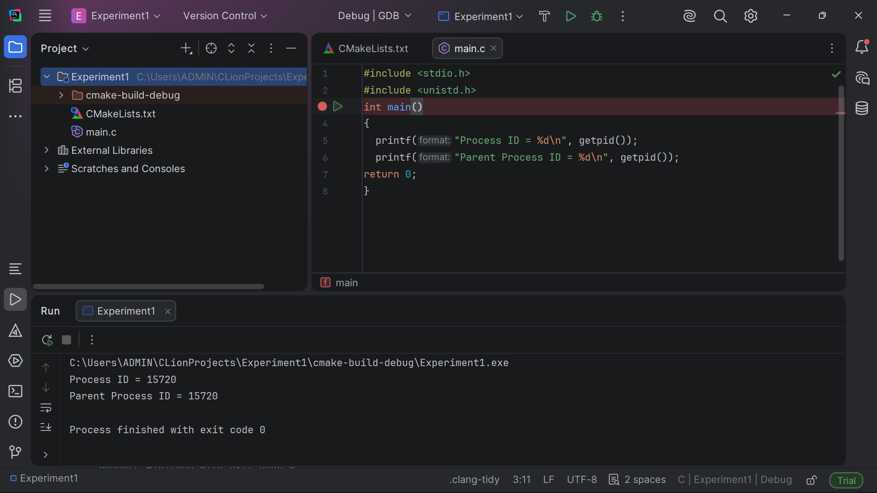

- Identify the system calls to copy the content of one file to another and illustrate the same using a C program

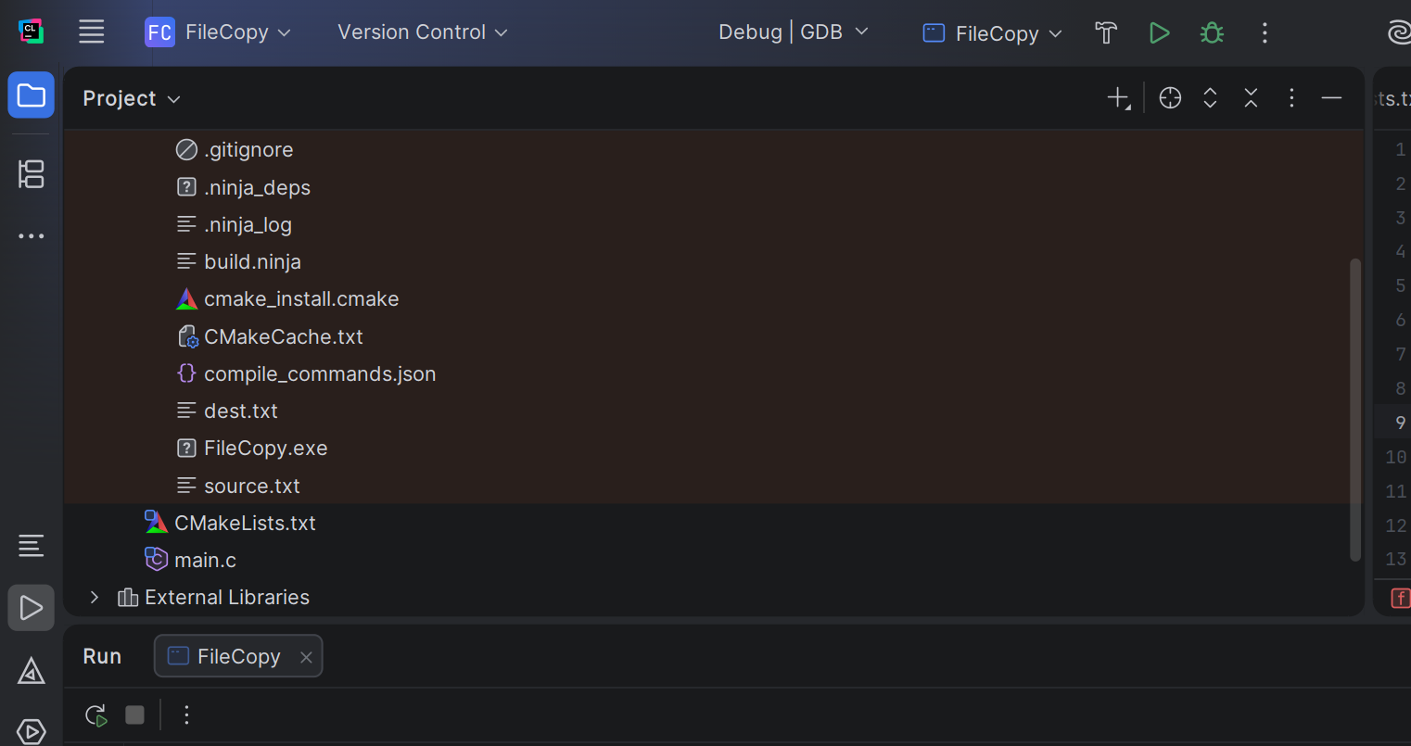

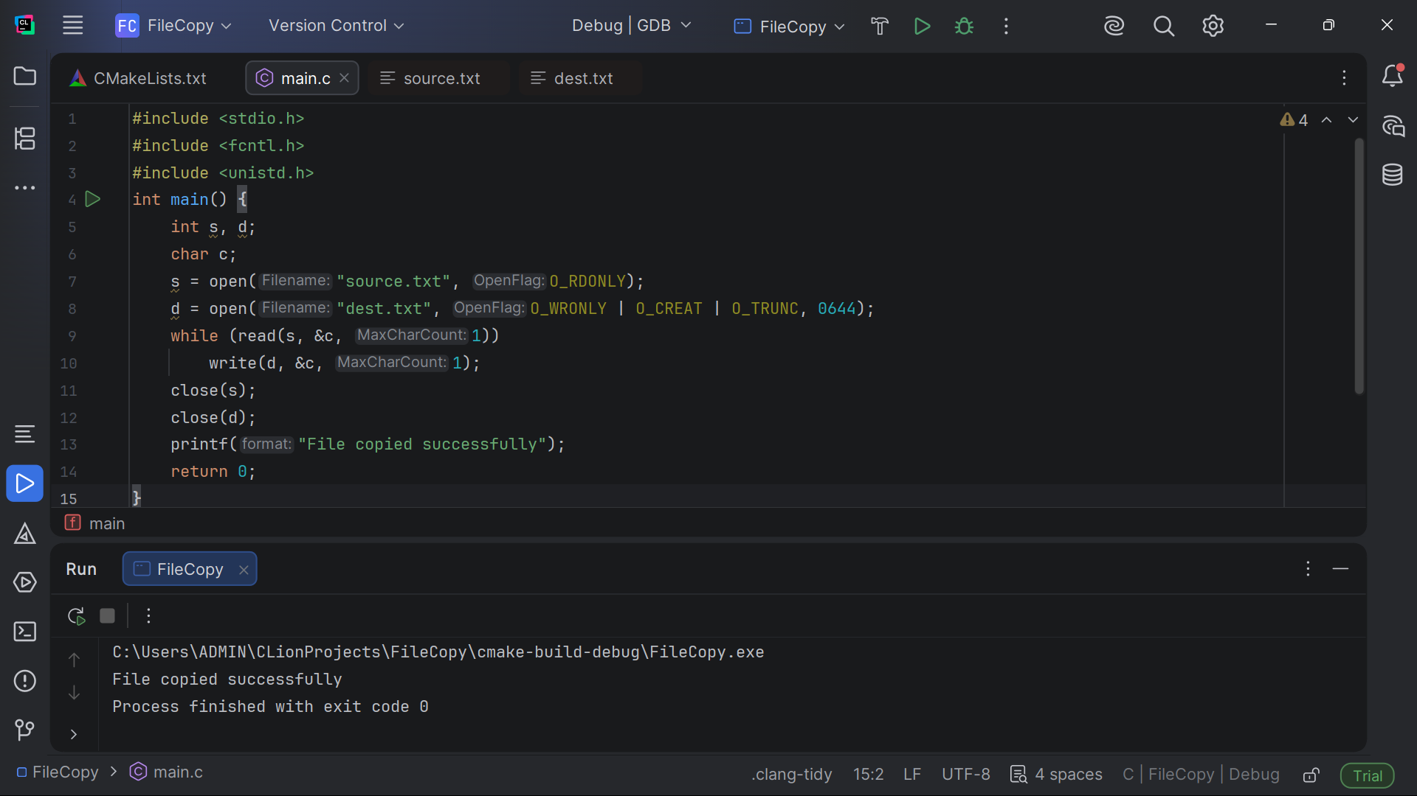

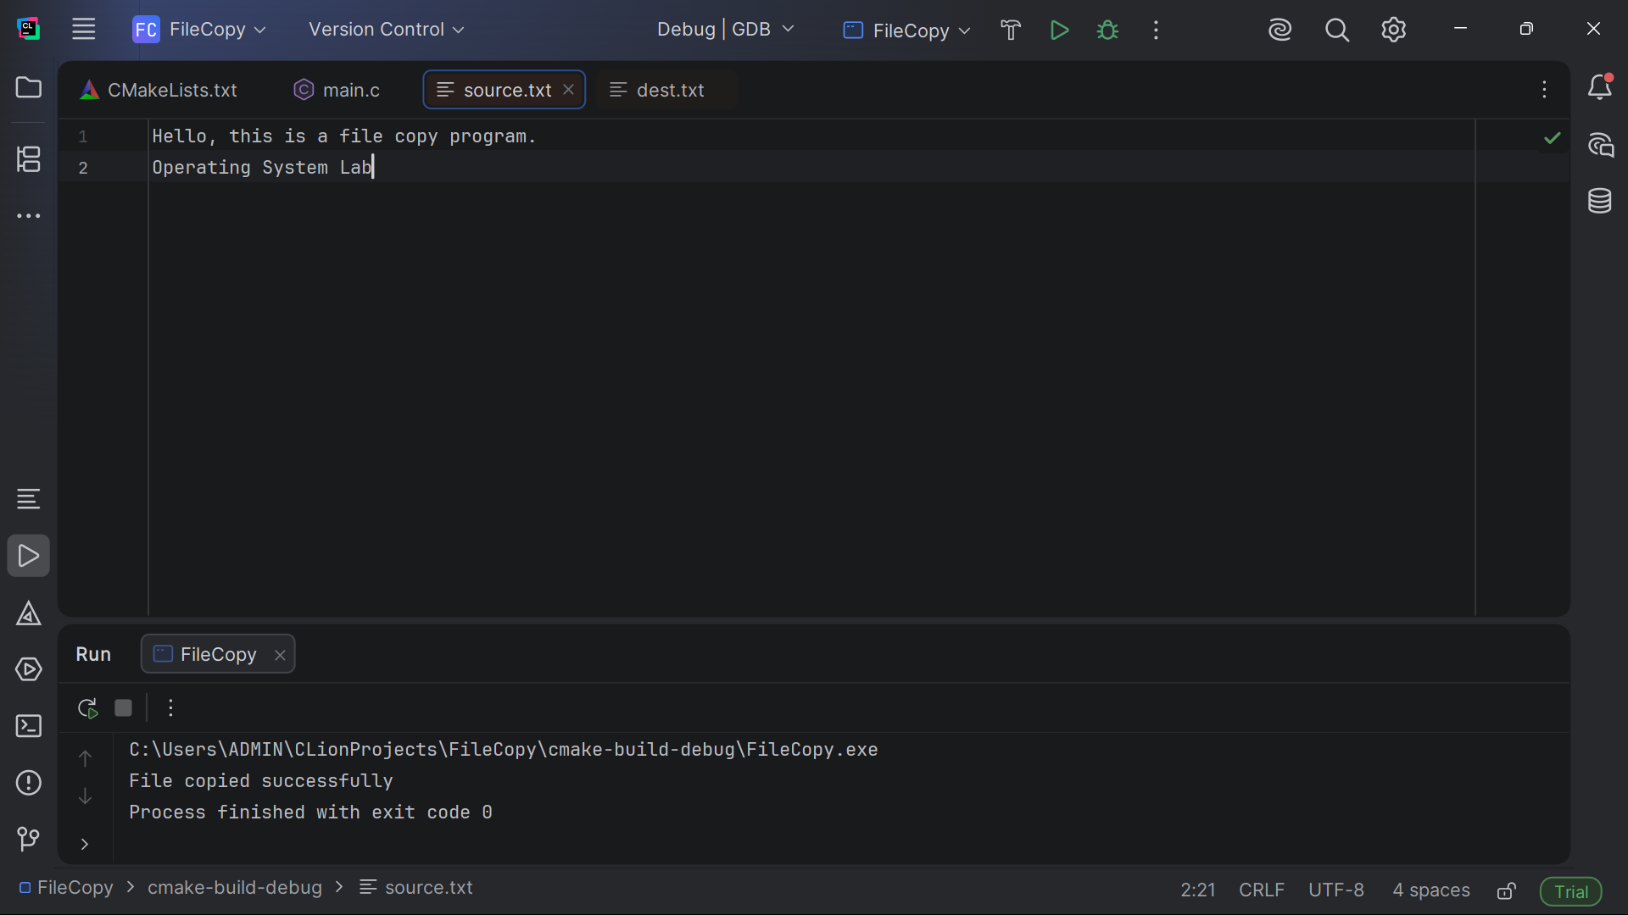

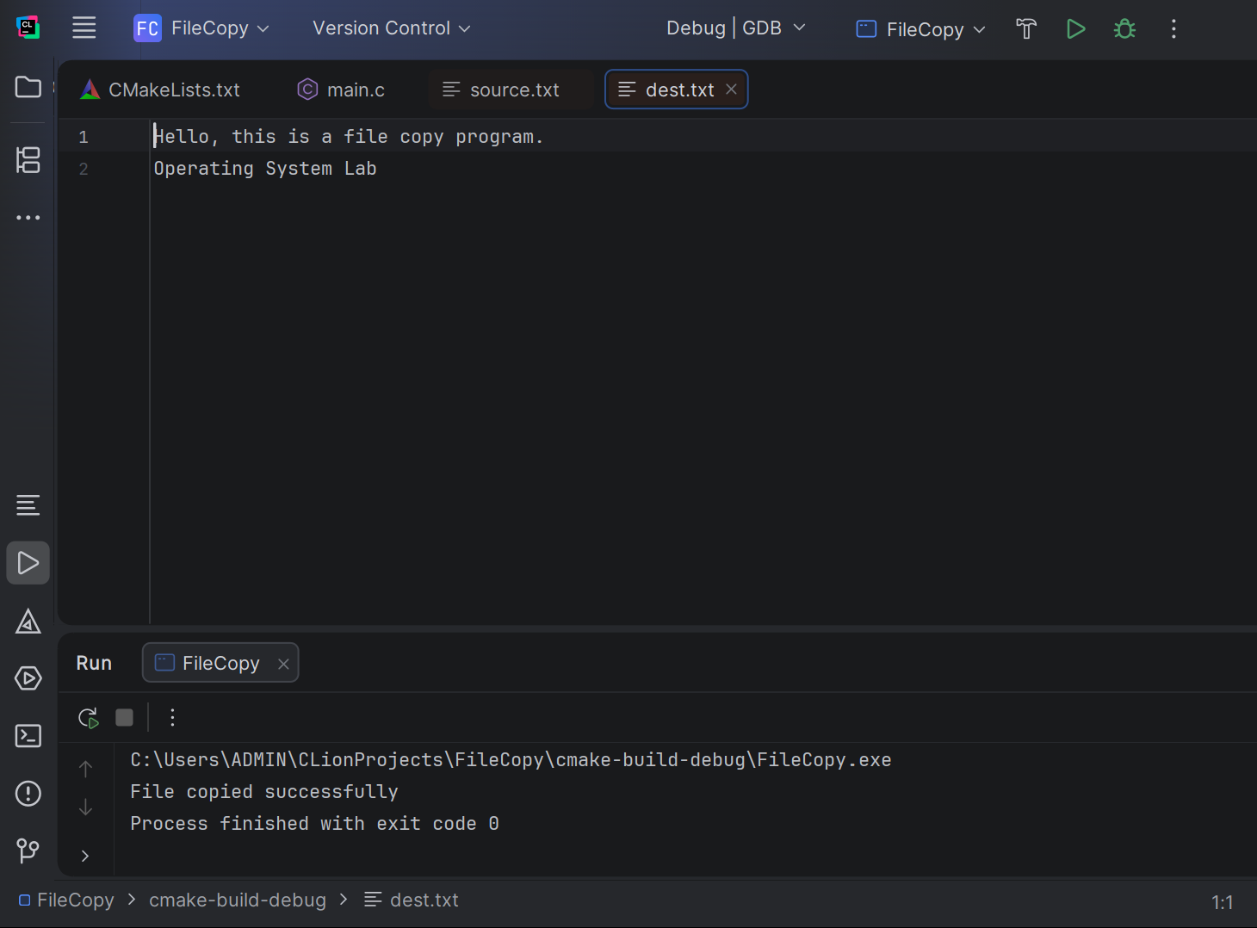

Github link:

https://github.com/192521075s/CSA0421-Operating-system.git

